**1. Configuring a Basic Spring Application**

**//pom.xml**

<project xmlns="http://maven.apache.org/POM/4.0.0" xmlns:xsi="http://www.w3.org/2001/XMLSchema-instance" xsi:schemaLocation="http://maven.apache.org/POM/4.0.0 https://maven.apache.org/xsd/maven-4.0.0.xsd">

<modelVersion>4.0.0</modelVersion>

<groupId>com.springcore</groupId>

<artifactId>Springcore</artifactId>

<version>0.0.1-SNAPSHOT</version>

<name>SpringCore and Maven</name>

<dependencies>

<dependency>

<groupId>org.springframework</groupId>

<artifactId>spring-context</artifactId>

<version>5.3.20</version>

</dependency>

</dependencies>

</project>

**//Then update the maven project**

**//Bookrepository.java**

package com.book.repo;

public class Bookrepository {

public String getBook() {

return "Psychology Of Money";

}

}

**//bookservice.java**

package com.book.service;

import com.book.repo.Bookrepository;

public class bookservice {

private Bookrepository bookrepository;

public void setBookRepository(Bookrepository bookrepository) {

this.bookrepository = bookrepository;

}

public void displayBook() {

System.*out*.println("Book: " + bookrepository.getBook());

}

}

**//App.java**

package com.book;

import com.book.service.bookservice;

import org.springframework.context.ApplicationContext;

import org.springframework.context.support.ClassPathXmlApplicationContext;

public class App {

public static void main(String[] args) {

ApplicationContext context = new ClassPathXmlApplicationContext("applicationContext.xml");

bookservice bookService = context.getBean("bookService", bookservice.class);

bookService.displayBook();

}

}

**//ApplicationContext.java**

<?xml version="1.0" encoding="UTF-8"?>

<beans xmlns="http://www.springframework.org/schema/beans"

xmlns:xsi="http://www.w3.org/2001/XMLSchema-instance"

xsi:schemaLocation="http://www.springframework.org/schema/beans

https://www.springframework.org/schema/beans/spring-beans.xsd">

<bean id="bookRepository" class="com.book.repo.Bookrepository"/>

<bean id="bookService" class="com.book.service.bookservice">

<property name="bookRepository" ref="bookRepository"/>

</bean>

</beans>

**File Structure:**

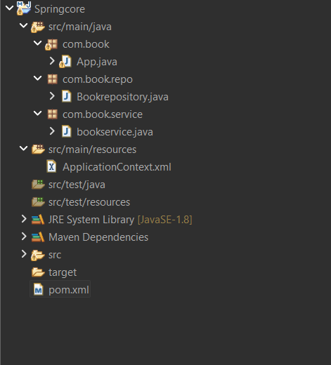

**Output:**

